Supplemental Figures

Supplemental Figure 1. Number of POP and HSP pairs found in 100 different simulations for treatments that sampled 100 individuals annually, where each row depicts a treatment for the number of years at the end of the time series that the sampling was conducted.

Supplemental Figure 2. Number of POP and HSP pairs found in 100 different simulations for treatments that sampled 1,000 individuals annually, where each row depicts a treatment for the number of years at the end of the time series that the sampling was conducted.

Supplemental Figure 3. Number of POP and HSP pairs found in 100 different simulations for treatments that sampled 5,000 individuals annually, where each row depicts a treatment for the number of years at the end of the time series that the sampling was conducted.

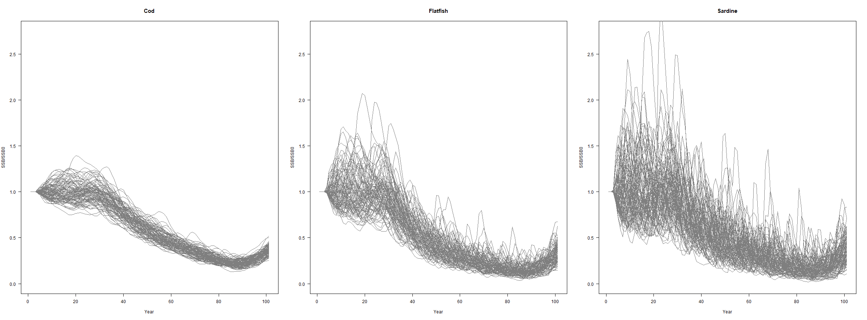

Supplemental Figure X. Depletion.

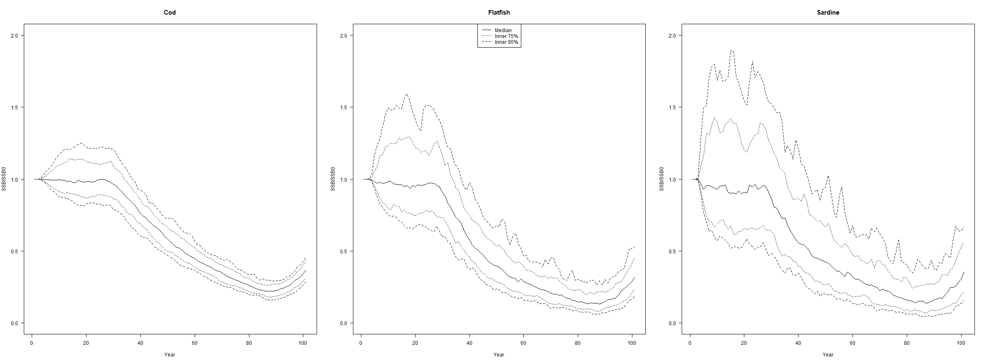

Supplemental Figure X. Depletion CIs.

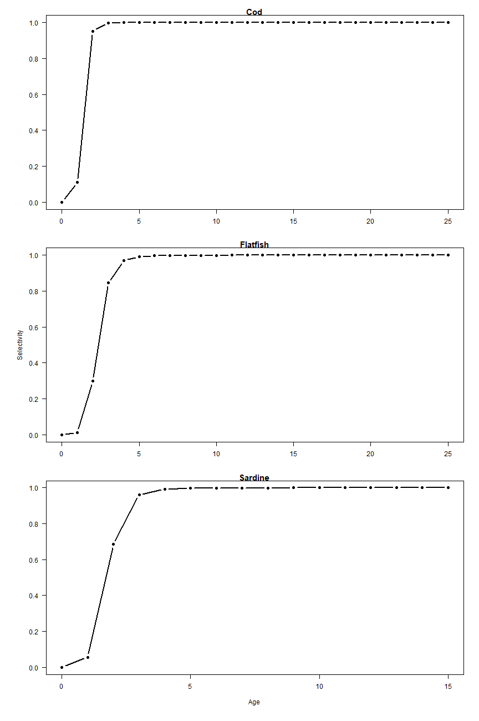

Supplemental Figure X. Selectivity of the different life history types.